Change Hardware compatibility of a VM (Either by clone/create new one) which is already created and configured using vmware workstation.
Aim: To change the hardware compatibility of an already created and configured Virtual Machine using VMware Workstation by upgrading or downgrading compatibility settings.
Procedure:
- Open VMware Workstation on the system.
- Select the existing Virtual Machine from the Library.
- Ensure the VM is in Powered Off state before modifying hardware compatibility.
- Right-click the VM ➜ Select Manage ➜ Change Hardware Compatibility.
- The Hardware Compatibility Wizard will appear — click Next.
- Choose the required compatibility version (Example: Workstation 16.x, 17.x, etc.).
- Select to create a full clone or modify the existing VM directly.
- Review the list of devices and features that may be added or removed due to compatibility change ➜ click Next.
- Verify changes and click Finish to apply the new compatibility setting.
- Power ON the VM and check whether it is functioning correctly with the updated hardware compatibility.
Output:
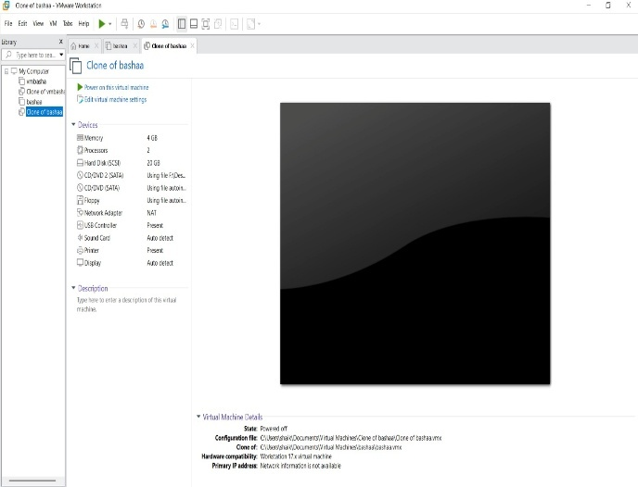
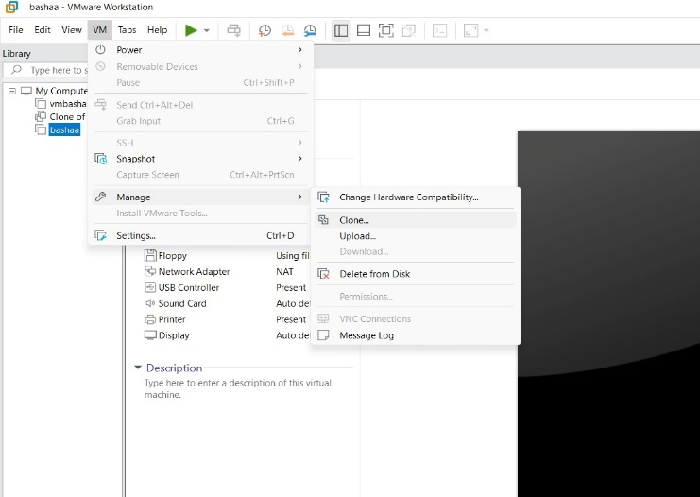

Result: The hardware compatibility of the Virtual Machine was successfully changed.
The updated VM worked properly with the selected VMware Workstation compatibility version.

